Hybris 6

B2B Assests

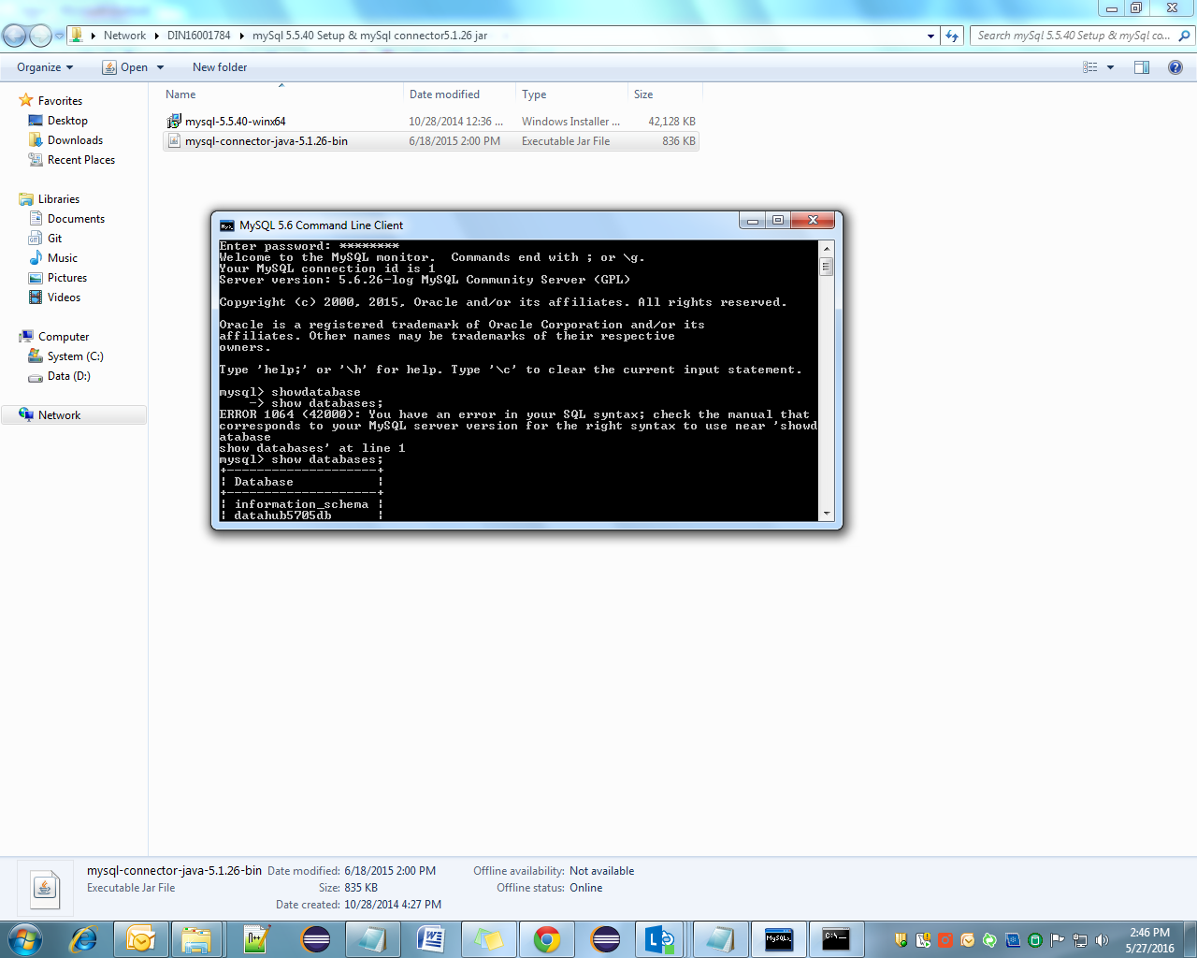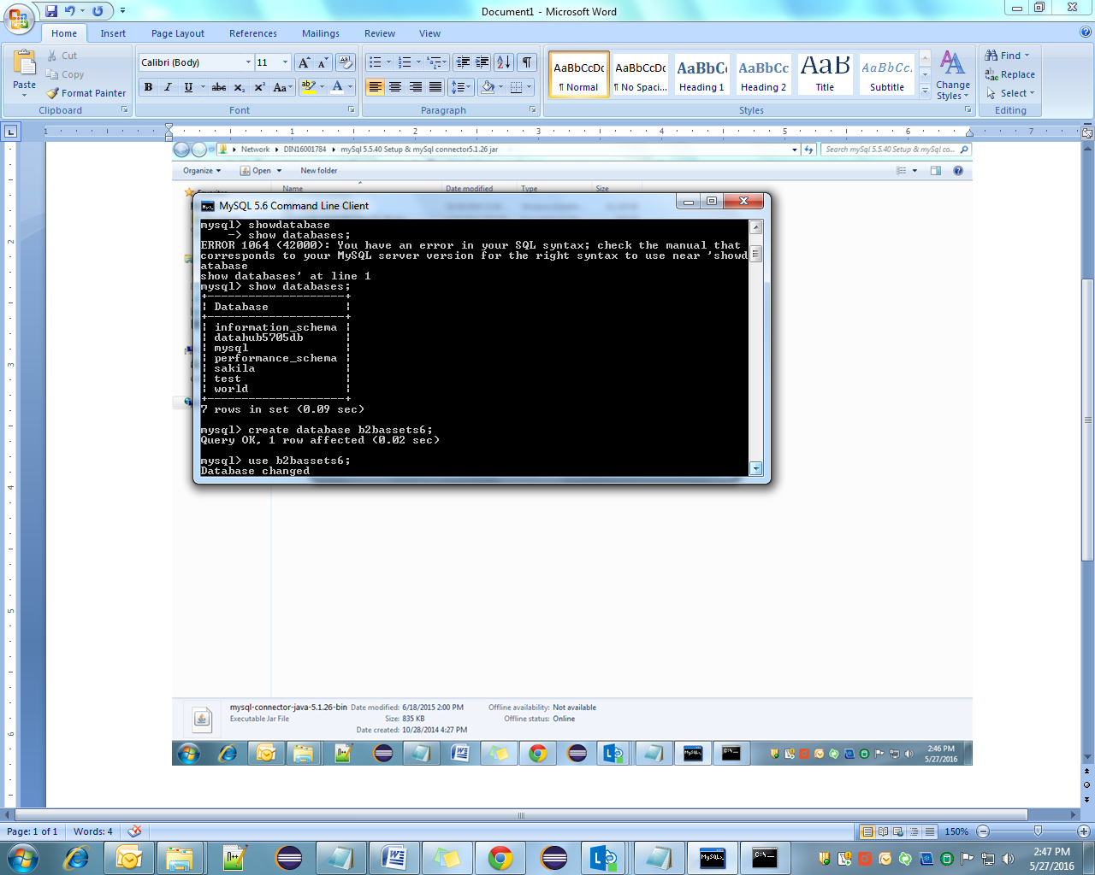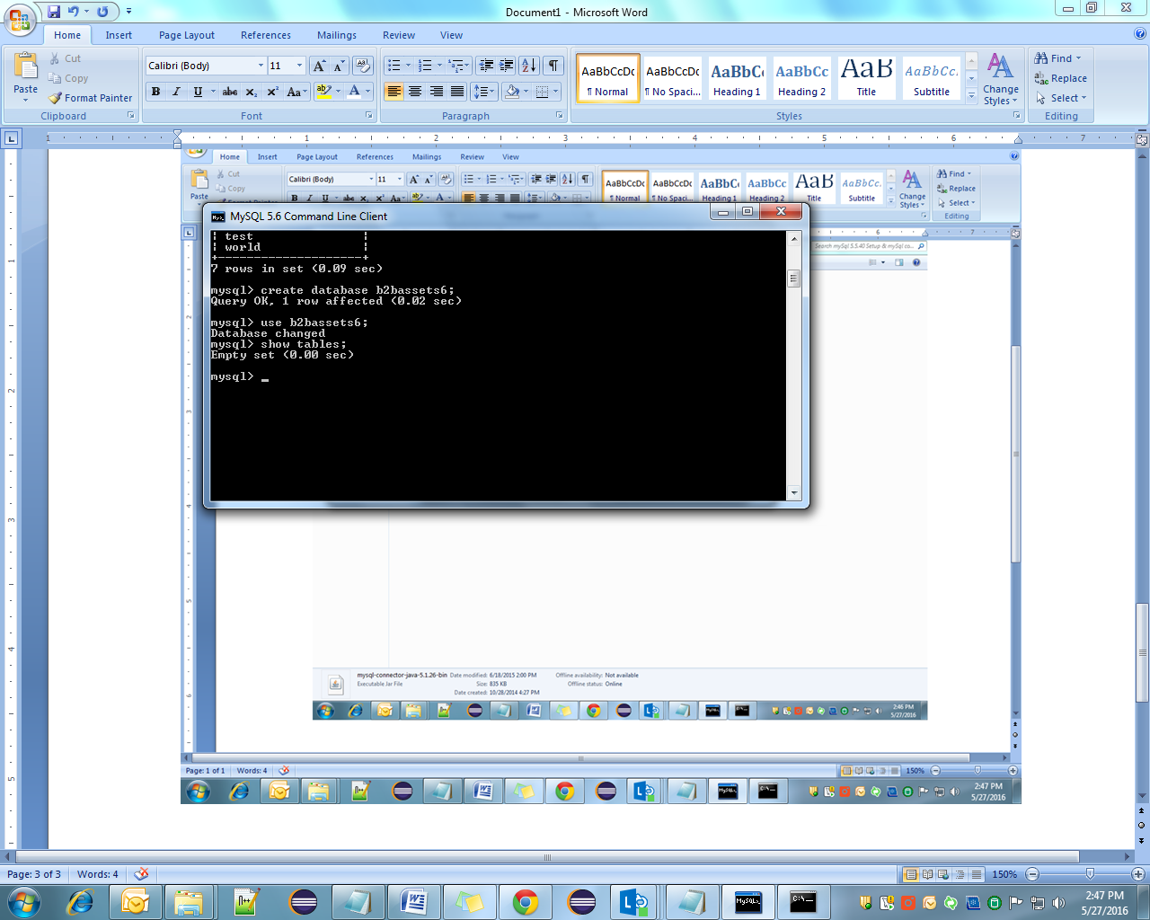

|  |
| --- |
| create new database in mysql and add connector in dbdriver |
| add connection properties in gradle file |
| Hybris extract kar naya wala |
| do ant module gen > b2bassets |
| copy b2bassets in b2b_acc plus recipe all 7 extensions and remove yaccelerator extns, replace yacceleratorestorefront with b2bassetsstorefront. |
| run gradle install bat |
| add addons in custom folder |
| then add in gradle also, make sure addons are properly added in gradle |
| b2bassetstest-->extensjoninfo.xml comment apparel and electronics stores |
| run gradle again  > install bat |
| ant clean all |
| hyrbis server and init |

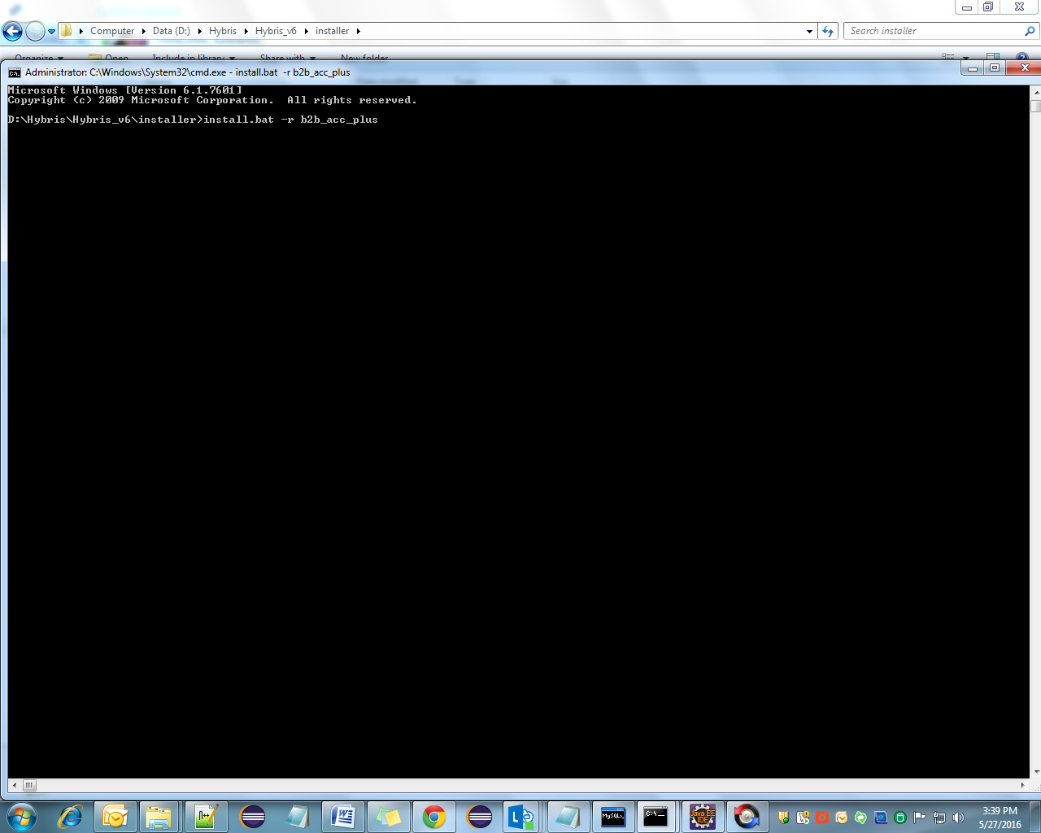

Change all addons local.properties and template file

